


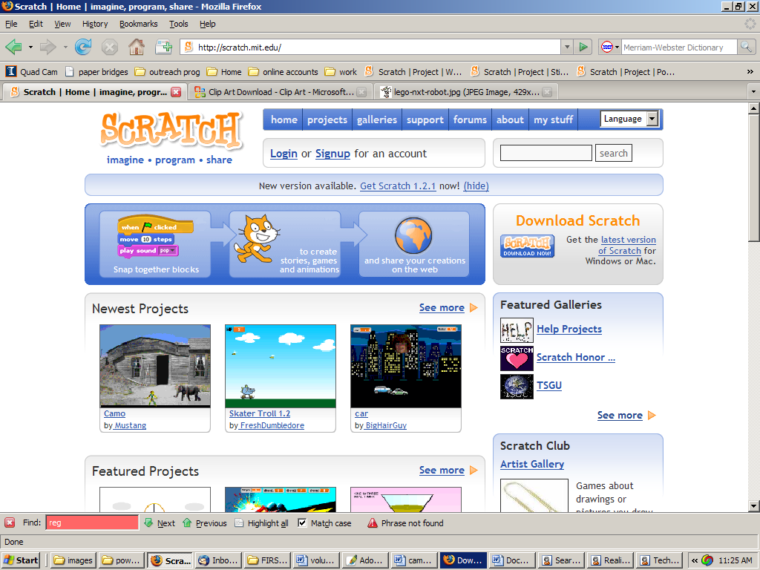
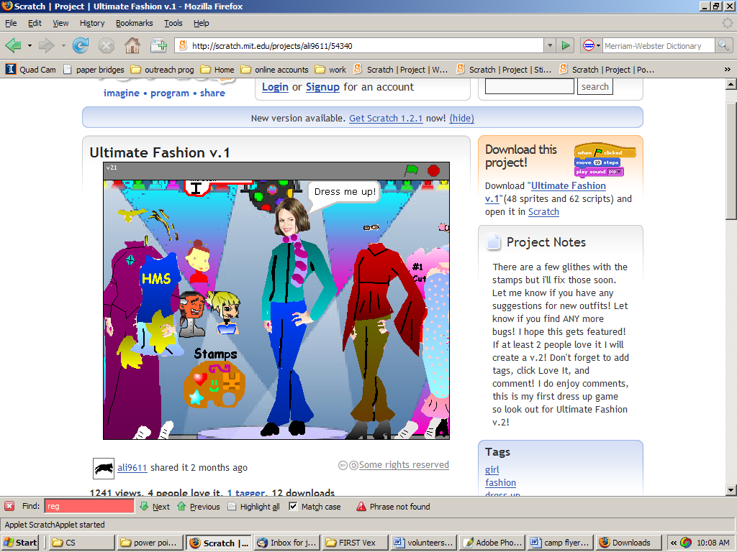

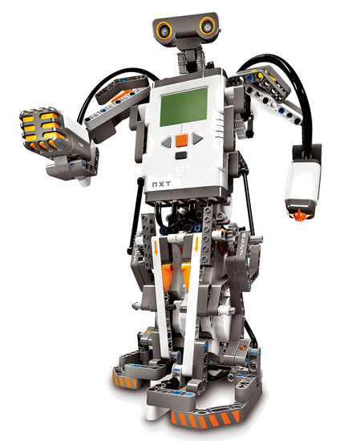
creative

technology

CAMP

@ GA Tech Savannah

5 Day Technology Camps
for Grade School, Middle School & High School Students

Middle School Session
Grades: | 6th - 8th | Activities:  - Storytelling through Animations  - Creating Interactive Games  - Kinetic Sculptures with LEGO Robotics
Dates: | July 7-11
Times: | 8:30-3:30  8:00 & 4:00 drop-off/pick-up available
Cost: | $200, lunches included

Middle School Session
Grades: | 6th - 8th | Activities:  - Storytelling through Animations  - Creating Interactive Games  - Kinetic Sculptures with LEGO Robotics  - Mobile Robotics with LEGO Robotics
Dates | July 14-18
Times: | 8:30-3:30  8:00 & 4:00 drop-off/pick-up available
Cost: | $200, lunches included

High School Session
Grades: | 9th - 12th | Activities:  - Creating Games and Animations  - Mobile Robotics with  Vex Robotics Systems and easyC
Dates: | July 7-11
Times: | 8:30-3:30
Cost: | $100, lunches included

Applications Available Feb 1
At <Insert URL>

